Next Generation Sponsorship
Sponsor Today! There are many opportunities to sponsor a child of the next generation, providing them with education and hope for their future.
I/We agree to support the work of African Action International for the care of orphaned and vulnerable children within its programs in East Africa by regular donation or sponsorship.
SPONSOR NAME: __________________________________________________
ADDRESS: ________________________________________________________
PHONE: ______________________EMAIL: ______________________________
SPONSORED CHILD: _______________________________________________
1. SPONSORSHIP: MONTHLY SPONSORSHIP (please circle)
- PRIMARY AGED CHILD $50 (Up to Primary Year 8)
- SECONDARY AGED CHILD $70 (Forms 1 to 4)
- TERTIARY and Vocational Courses $120
Sponsors of Primary and Secondary students are invited to purchase a school uniform in October/November of each year at a cost of $70.00.
2. DONATION - EDUCATION FUND
NOTE: Not all the students supported by AAI have the ongoing support of a Sponsor, and our Education Fund is used to meet some of their needs to attend school.
- $10, $20, $40, $60, $80 Monthly (please circle)
- One off donation $______
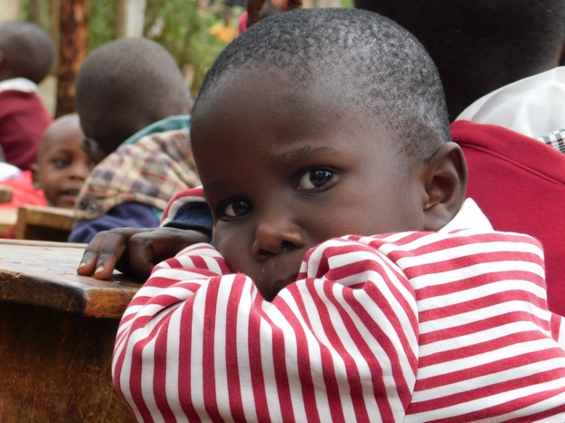
I will forward funds to AAI bank account by the 20th day of each month. Account Name: African Action Int.
BSB: 063 530 Account: 1028 6392
Please return this slip to:
Max and Jill Sargent, 25 McDonald St MORWELL, 3840
Or email maxsargent@icloud.com

Thank you!

